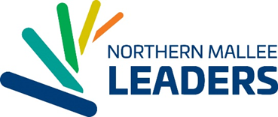
Name
Organisation
Address
Date…………………………………………..
Re: Letter of Commitment to provide a Scholarship to support the 2018 Northern Mallee Leaders Program
Dear ……..
NML Inc. is the peak provider of community leadership programs for north west Victoria and southern NSW, developing leaders for the Mildura Rural City Council and Wentworth Shire Council local government areas. As a not-for-profit organisation, NML Inc. is seeking support from a range of organisations or individuals to enable our community leadership initiatives to continue. One way to support the program is through scholarships which provide financial support for our flagship Northern Mallee Leaders Program (NMLP) participants. This annual leadership program offers 25 people the opportunity to embark on a journey of self-discovery, personal and professional growth and as a result, grow our community.
Scholarships are incredibly valuable in enabling participation in the NMLP and scholarship sponsors will be acknowledged as follows:
- You or a representative from your organisation to present a certificate at the NMLP launch to your scholarship winner
- GRADUATION – 2 complementary tickets to attend the 2018 NMLP gala Graduation.
- Organisation logo to be included in the 2018 NMLP Year Book.
- Inclusion in the NML Inc. website logo display
To offer a scholarship, please complete the following section, then email or post to NML Inc.
……NAME OF ORGANISATION/INDIVIDUAL…………… is very supportive of Northern Mallee Leaders Inc. in selecting an applicant as a scholarship recipient and providing them with an opportunity to participate in the 2018 Northern Mallee Leaders Program.
……NAME OF ORGANISATION/INDIVIDUAL…………… commits the sum of $3,000 to be paid on receipt of invoice from NML Inc. We prefer /prefer not to be publically acknowledged for our support. (Please cross out whatever is not applicable)
NAME OF ORGANISATION/INDIVIDUAL nominates …………… …NAME OF PERSON RESPONSIBLE FOR PAYMENT of INVOICE
Their contact details are as follows:
…Email
…Phone Number
NAME OF ORGANISATION/INDIVIDUAL nominates …………… …NAME OF PERSON AS KEY REPRESENTATIVE FOR COMMUNICATION AND LIASION WITH NML Inc.
Their contact details are as follows:
…Email
…Phone Number

Signed………………………………………………… Date…………………………………………

Role in Organisation……………………………..

On behalf of NML Inc. I thank you most sincerely for your commitment to the future of our community.
With much appreciation
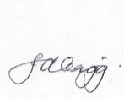
Jen Grigg
Executive Officer
Northern Mallee Leaders Inc.
PO Box 10311
Mildura 3500

Mobile: 0427 438 111
Email: executive @nml.org.au

