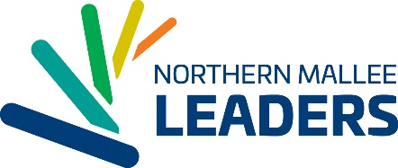
2018 PROGRAM CALENDAR
Indicative Program dates and themes for 2018 are as follows (subject to change):
Date | Theme | Timing | Location
*Thursday February 8 | 2018 Program Launch | Afternoon/Evening | Mildura
*Friday February 23 (evening), Saturday 24 & Sunday 25 | Opening Retreat Weekend | 2 Days/2 Nights | Lake Cullulleraine
Wednesday March 7 | Community Development | 1 Day/Evening | Red Cliffs
Tuesday March 20 | Arts and Culture | 1 Day/1 Dinner | Mildura
Wednesday April 18 | Media/Communication | 1 Day | Mildura
Tuesday May 1 | Regional Economy and Tourism | 1 Day | Wentworth
Wednesday May 23 | Vision of the Region Dinner | Dinner | Mildura
*Sunday June 17–Wednesday June 20 ** | Metropolitan Communities/State Issues/Social Justice | 4 Days/3 Nights | Melbourne **
Tuesday July 17 | Health and Well Being | 1 Day | Mildura
Thursday July 26 | Business Network Event | Key Event | Mildura
Thursday August 2 | Youth in our Communities/Education | 1 Day/Evening | Mildura
*Sunday August 19 – Thursday August 23 ** | Understanding our Political Landscape/National Issues | 5 Days/4 Nights | Canberra**
Thursday August 30 | Governance/Justice | 1 Day | Merbein
Thursday September 20 | International Leadership | 1 Day | Mildura
Sunday October 7 & Monday October 8 | Food, Water and the Environment | 2 days/1 night | Robinvale
*Saturday October 20 and Sunday October 21 | Final Retreat Weekend | 2 Days/1 Night | Ouyen
*Thursday November 8 | 2018 Graduation Ceremony | Evening | Mildura
Notes: Shading denotes overnight stays. * indicates compulsory activities.
** TBC subject to confirmation of parliamentary sitting days
OPTIONAL – VRCLP COMBINED PROGRAM DAY (Melbourne) – Tuesday 18th September - tbc
Total of 23 program days plus Launch, three key events, a session with Mildura Rural City Council and Council meeting and VRCLP Combined Program Day (optional).

